System-wide Delivery of Medicines Homecare

Technical System Specification

Contents
Executive Summary 5
Background and Overview 6
Introduction 6
Hackett Report 7
Homecare Policy 7
Document Objectives 7
Homecare Process 9
Stakeholders 9
Patient Journey Overview 10
Hot Spots 11
Homecare Approach 13
Case Studies 14
Summary 14
UCLH Case Study 15
North Bristol Case Study 18
Leeds Case Study 21
Framework Constraints 22
Strategic Papers 22
Case Study Findings 23
Homecare Options 24
Overview 24
Option 1 – Link Existing System Electronically 24
Option 2 - Link Existing System Electronically (& Stock Control Module) 25
Option 3 - Enhanced Homecare Provider System 25
Option 4 – New Centralised Pharmacy System 26
Recommended Option 27
Logical System Components 28
Functional Use Case Packages 28
Non-Functional Requirements 28
Use Case Mapping to Business Processes 29
Patient Use Cases 31
Overview 31
Login & Security 31
Dashboard/Homepage 31
Choose Delivery Time 32
View Patient Records 32
Maintain Patient Records 33
Secure Messages 33
Reminders 34
Clinical Use Cases 35
Overview 35
Login & Security 35
Dashboard/Homepage 35
Select a Patient 35
View Patient Records 36
Maintain Patient Records 36
Import a Prescription 36
Secure Messages 36
Pharmacy Use Cases 37
Overview 37
Login & Security 37
Dashboard/Homepage 37
Select a Patient 37
View Patient Records 37
Maintain Patient Records 37
Check Prescription 37
Create Orders 38
Place Orders 39
Secure Messages 39
Homecare Providers Use Cases 40
Overview 40
Login & Security 40
Dashboard/Homepage 40
Select a Patient 40
View Patient Records 40
Maintain Patient Records 40
Arrange Delivery 40
Delivery 41
Create Invoice 41
Submit Invoice and Proof of Delivery 42
Secure Messages 42
Pharmacy Finance Use Cases 43
Overview 43
Login & Security 43
Dashboard/Homepage 43
Select a Patient 43
View Patient Records 43
Reconcile Invoices and Proof of Delivery 43
Process Invoice 44
Secure Messages 44
Trust Finance Use Cases 45
Overview 45
Process Payment 45
Other Use Cases 46
Overview 46
KPIs 46
Reports 46
Appendix 1 – RCP Health and Social Care Standards for Electronic Records 48
Appendix 2 – Ideal Patient Journey 50
Appendix 3 – Technical Option Examples 51
Centralised Pharmacy System Option 51
Enhanced Homecare Provider System Option 52
Electronic transfer of Prescriptions Service Option 52
Appendix 4 – References 54
Appendix 5 – Glossary of Terms 55

Executive Summary
Homecare Success Story
The Hackett report shows that Homecare is a victim of its own success, with Homecare growth rates out stripping investment and supply with some Homecare Provider’s now turning away new patients as the current Systems, Resources and Procedures are maximised to full capacity. There is also evidence of quality and performance issues for existing patients.
This document takes the lessons learnt from 3 of the better placed Trust/Organisations as Case Studies to show how automation has helped them overcome some of the following manual & repetitive “hot spots”:
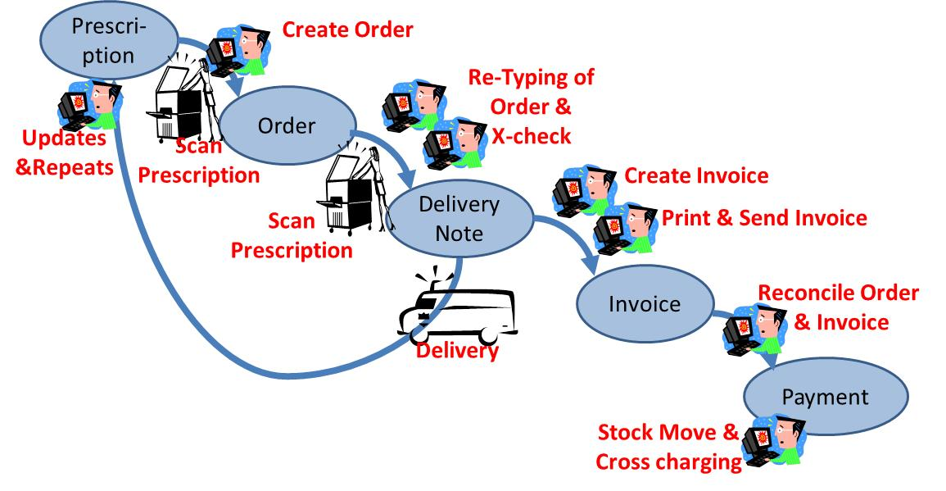
Figure 1 - Current Hot Spots
Homecare Automation – the way forward
This Technical System Specification conclusively shows that the only way to safely and cost effectively expand Homecare is to automate the Systems and Procedures. This could be achieved central by the NHS or by each Trust separately by extending existing Systems or procuring a new System(s).
To increase Homecare capacity and reach new Homecare patients so the NHS continue to reap the rewards and benefits that Homecare services brings any Homecare system would need to have:
- An Internet and mobile Portal for Patients
- Multi-layered “need to know” security model to protect confidential details
- Delivery a End-to-end Patient experience from initial clinical consultation to Homecare delivery
- Remove manual repetitive steps, such as re-keying
- Flexible architecture so Clinical, Pharmacy, Homecare Providers & Financial can integrate seamlessly using a modern innovative approach
- Fulfil the Homecare Requirements as captured in this TSS (in the Use Cases), including:
  - Use electronic data transfer for e-Prescribing, e-Ordering, e-Invoicing, e-Proof of Delivery
  - Homecare module for (virtual) Stock Control
Homecare Roadmap
Homecare recommended plan (as defined in the Business case) has the following milestones and deliverables:
Figure 2 - Homecare Roadmap

Background and Overview

Introduction
The Government puts patients at the heart of the NHS and everything that it does and is seeking to empower and liberate clinicians to innovate with freedom to improve health services.
It also recognises that Homecare medicines can transform peoples’ lives and add enormously to life expectancy.
Homecare medicine brings the redesign of NHS services and recognition of the role that medicines play, together, around a single natural focus.
The use of medicines plays a vital role in the delivery of high quality care and accounts for over 12% of NHS expenditure. In 2009 -10, the NHS drugs bill was approximately £11.9 billion, equivalent to around 12% of the entire NHS budget and was the biggest single item of spend after staff. Of this around £7.9 billion was spent in primary care and £4 billion in secondary care.
The Homecare drug cost is estimated at over 25% of the secondary care - £1 billion, and growing at 4.6% per year. Hence in 2011, the Chief Pharmaceutical Officer initiated the Hackett Report to review homecare because:
- The rapid expansion of homecare medicine with a lack of national visibility and was concerned that the DH was unable to advise ministers on policy options.
- The related the DH’s inability to secure a national understanding of homecare medicine with concerns about how the NHS managed this business, and the thought it was giving to strategic intent.
- The recognised that ‘getting homecare medicine right’ was important to taxpayers and patients, not least because of the contribution that homecare medicine supply will play in delivering a strategic shift of caring for patients in their own homes.

Hackett Report
Mark Hackett, chief executive University Hospital Southampton NHS Foundation Trust, led the work. The report made a list of recommendations to improve the financial and clinical governance arrangements for patients receiving medicines via the homecare route.
In April 2012 Mark Hackett established a Homecare Medicines Strategy Board to oversee a national implementation of the recommendations. The steering board work streams (and their key deliverables) are as follows:
- Patient engagement:
  - A patient charter
  - A model for patient engagement
  - A guide for patients on patient choice
- Acute Trust engagement, governance and clinical relationships:
  - A guide to good governance for acute trusts
- Systems: Homecare modules and functionality:
  - Short term recommendation on system solutions
  - Output Based Specification for a new homecare medicine system solution (i.e. precursor to this document)
  - Technical System Specification for a new homecare medicine system solution (i.e. this document)
  - Business Case
- Toolkit / Handbook (reference 2) and Standards (reference 9):
  - A framework of standards for homecare medicines
  - A toolkit for the NHS to support the management of homecare medicines
  - Outline expertise and knowledge for the operation of homecare medicines
- Development of procurement model:
  - A set of procurement standards
  - Improvements to the existing procurement process.

Homecare Policy
Homecare is defined as a service that regularly delivers medicine supplies and associated care, directly to a patient’s choice of location. Homecare services are split between those which are set up by the Pharmaceutical industry for individual products and those services which are contracted to an NHS specification. There are different levels of Homecare service from simple dispensing and delivery (low tech) to more complex aseptic preparation and the inclusion of nurse administration (high tech).
The use of a homecare service should not reduce or alter the NHS duty of care to patients. The Trust/Organisation and the patient’s clinical team will retain responsibility for the clinical aspects of a patient’s treatment. Areas of responsibility need to be clearly defined for all parties with SLAs (or equivalent) to guarantee quality service.
Please note, the model policy for Homecare can be found in the Expertise, Toolkit / Handbook (reference 2) and Standards (reference 9).

Document Objectives
This Technical System Specification (TSS) defines logically how an integrated Homecare Solution could be implemented, based on the requirements agreed in the Output Based Specification (OBS). Basically:
- OBS is a business requirements document that “wraps” the required functionality of a system (or systems) but does not define how the functionality is to be achieved
- TSS takes this one step further and allocates functionality logically to Homecare Pharmacy System components and the flow of functionality needed
The TSS maps the Homecare end-to-end process from the Patient prospective using Swim-lanes to identify all the key Stakeholders. The Swim-lane is used to identify the problem areas “Hot spots” with the Homecare end-to-end process.
Three real-life Case Studies have also been recorded of successful Trusts who have already automated certain Homecare process electronically and began to resolve the “Hot spots”
The TSS then considers possible Options for delivering integrated Homecare processes so we can begin to visualise the architecture/structure and begin the estimation/tendering. These components will need to be logical as well as flexible because each Trust/Organisation has a different environment and have different IT systems already in place (for example there are 8 Pharmacy systems, each Homecare Provider will have their own systems/CRMs, etc.).
The TSS then adds further detail as UML Use Cases to show the sequence of events for each logical system. Use Cases are a standard industry wide technique so any Analyst, Developer and the Business user understand logical flows without needing to learn UML methodology.
This TSS will then be used to derive indicative costs and associated benefits for the Business Case.
The Homecare Medicines Strategy Board deliverables (Toolkit/Handbook, OBS, TSS and Business Case) will then be used to secure funding for an OJU tendering process or using in-house services (such as Shared Business Services).
Once a consultancy (or equivalent) is in place they would need review the existing Trust/Organisation & Homecare Provider systems to produce a Physical Design that is:
- Flexible – so different systems can be bolted-on
- Extendable – to allow for growth
- Manages Data Ownership – between the various systems
- And above all secure.

Homecare Process

Stakeholders
The following shows the Homecare stakeholders. Please note, Roles and Responsibilities for these stakeholders have been defined as part of the Expertise, Toolkit / Handbook and Standards Workstream (see references 2 & 9):

Commissioners
Dept of Health / Commercial Medicines Unit
Homecare Providers
Patients
Homecare
System
TRUST FINANCE
Control & reporting
NHS COMMERCIAL
Contracting & Performance
GOVERNANCE
Regulators & Assurance
CLINICIANS
GPs, Doctors & Nurses
PHARMACY
Clinical, Procurement & Finance
External
Internal

Patient Journey Overview
The following shows how each of the above Stakeholders interact during the Homecare end-to-end process in the form of a swimlane:
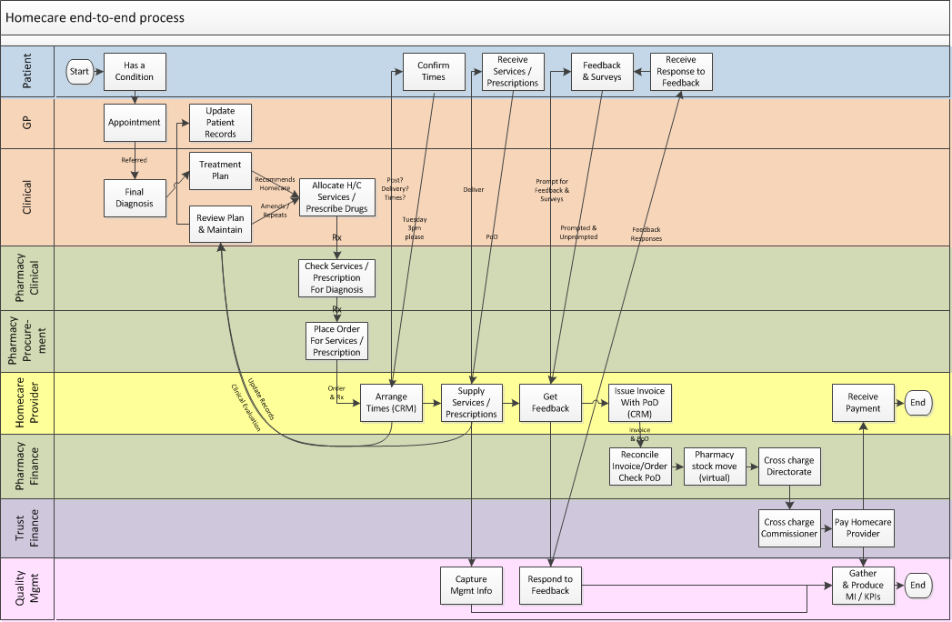

Most of the processes on the previous page are self-explanatory, however for further explanation of these process are please see the Case Studies and the Logical System Components/Use Cases (later in this document).

The above swimlane of the Homecare end-of-end process is used throughout the TSS to measure the process effectiveness and is used to optimise Homecare by forming the cornerstone to help describe how possible solutions could be introduced.

Hot Spots
Areas of the process which introduce unnecessary or repetitive work-arounds are called “Pain Points” or “Hot Spots”. Hence for any process to become more effective the “Pain Points”/“Hot Spots” must be removed or minimised, this could be through a variety of different methods such as automation or electronic communication or even changing the process itself.

For Homecare these “Hot Spots” are typically caused by manually processes whilst:
- Re-typing of Prescriptions, Patient Details, Orders & Invoices, Goods Receipt Notes:
- Scanning/Photocoping of Prescriptions, Patient Details, Orders, PoD & Invoices
- Delivery of the drugs/services which cannot be avoided anyway.

These “Hot Spots” are:
- Manual & Slow
- Costly to Pharmacy as well as to the Homecare Providers
- Reduces Capacity of both the Pharmacy and Homecare Providers
- Compromises patient medical safety
- Compromises patient data

The following shows the homecare swim-lane and some of the “Hot Spots”:
Create Order
Scan
Prescription
Dual Re-Typing of Order
& X-check
Create
Invoice
Print & Send Invoice
Reconcile Order
& Invoice
Delivery
Updates
&Repeats
Stock Move &
Cross charging

Homecare Approach
Simply removing the manual “Hot Spots” would vastly increase the Homecare efficiency which would produce significant savings as well as improving capacity and increasing Patient security (as already highlighted in the OBS).

Following an “Enter Once Use Many” approach would resolve nearly all the above “Hots Spots”, however to achieve this would require automating all Homecare Pharmacy Systems electronically as follows:
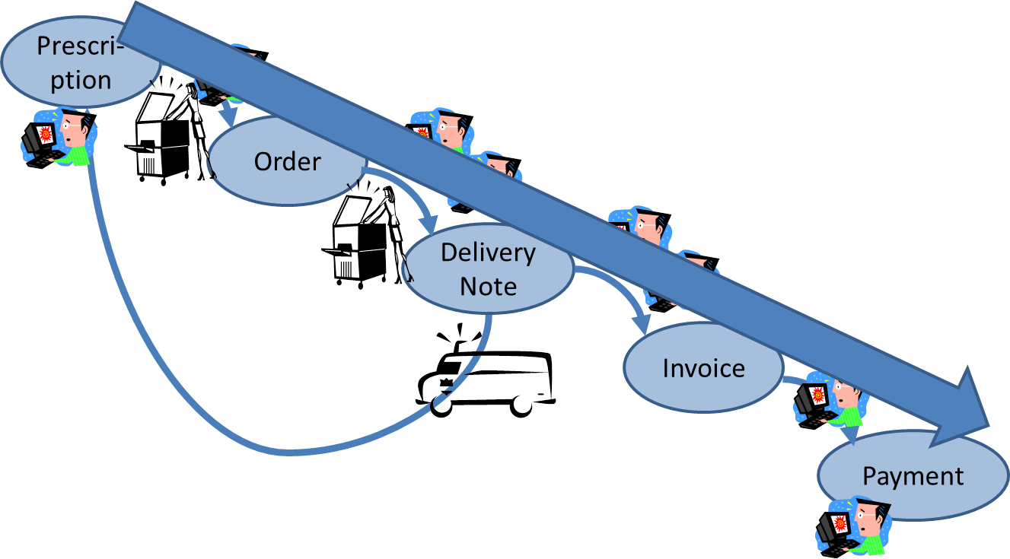

Case Studies

Summary
The following Case Studies show the successes and achievements that have already been made automating Homecare Pharmacy Systems and removing all but one “Hot Spot” - Order Creation from the Prescription (ignoring Delivery).
If it were technically possible to ‘merge’ these 3 Case Studies together some-how then the “Hot Spots” would almost be resolved entirely. The following shows the automotive coverage of all 3 Case Studies (from UCLH, North Bristol & Leeds) when overlaid on the main Homecare swimlane process (green is automated & red is manual):

Create Order
Delivery

UCLH Case Study
Already Automated
The University College Hospital College Hospital (UCLH) use an “Improve the Present whilst working on the Future” approach to Homecare and quickly came to the conclusion that reducing the re-typing is the secret to success & efficiency. With this aim UCLH enhanced their PIMS system, by sensibly placing a web front-end application. This has massively enhanced the system and reduced the departments burden/pain as well as reducing the possibility of re-typing errors – ultimately saving costs. Most notably sending electronic Orders to the Homecare Providers, receiving electronic Invoices and fully automating the Pharmacy Finance (booking in/out of stock and cross-charging to directorates)
The UCLH have extended their current PIMS system, by sensibly placing a web front-end application. This has massively enhanced the system and reduced the departments burden/pain as well as reducing the possibility of re-typing errors – ultimately saving costs.
The web front-end application has increased the functionality beyond that would be given by some out-of-the-box offerings, all using existing PIMS system rather than re-inventing the wheel.
The following shows the automotive coverage of the existing UCLH processes when compared to the main Homecare swimlane process (green is automated & red is manual)

The above UCLH Homecare process is described in more detail below:
Initiator | Action | Disadvantages | Advantages
Clinician | Paper prescription created for Homecare Drugs | Manual process, slow, risk of misplaced prescriptions
Pharmacy Clinician | Manually fully check all new Prescriptions and partially check the repeat Prescriptions | Manual process, slow, risk of misplaced prescriptions
Homecare Coordinator (within Pharmacy Procurement) | Use CoMapping.com (info, contacts, etc.) as an aid to understand the Prescription to add Delivery Homecare Services also as a Training Tool |  | Quick simple to use and build up a knowledge base
Pharmacy Procurement | Create a Reference# (Order) in iPIMS | Manual re-typing the prescription. | iPIMS prepopulates Patients & Cost-centre details using previous Order for each treatment area
Pharmacy Procurement | Electronically send the Order to Homecare Providers | The majority are manually sent, however there are plans to expand the electronic interface to other providers | Could do all electronically if other Providers upgraded
Pharmacy Procurement | The original paper Prescription with the Reference# is either posted or collected by the Homecare Providers (regardless whether they have already received an electronic order or not) | Manual process, slow, risk of misplaced prescriptions
Homecare Provider | Manual scanning of Prescription | Manual process, slow, risk of misplaced prescriptions
Homecare Provider | Re-typing to create the Homecare Providers Order and Patient Details in their systems | Manual re-typing process, slow, risk of misplaced prescriptions
Homecare Provider | Arranges Delivery Times with the Patient
Homecare Provider | Delivers Services/drugs and obtains Proof of Delivery
Homecare Provider | Electronically send the Proof of Delivery (Advanced Shipping Note) to Pharmacy Procurement |  | Early notification of delivery
Homecare Provider | Creates an Invoice (with the Reference#) | Manual complex process to generate the different type of invoices
Homecare Provider | Prints & sends the Invoice to Pharmacy Procurement together with the Proof of Delivery (ASN) | The majority are manually processed, however there are plans to expand the electronic interface to other providers | Could do all electronically if other Providers upgraded
Pharmacy Procurement | Check a number of patients every month to ensure they have received their Homecare Services/drugs |  | Quicker than checking for every Proof of Delivery
Pharmacy Procurement (Finance) | Reconcile the Invoice and Order in PIMS, using the Reference#, Price, Quantity | The majority are manually reconciled, however there are plans to expand the electronic interface to other providers | Could do all electronically if other Providers upgraded
Pharmacy Procurement (Finance) | Cross-charge the Homecare Services/drugs to the Pharmacy (equivalent to a virtual stock move to say they have “Arrived” & “Issued to cost-centres”) | The majority are manually processed, however there are plans to expand the electronic interface to other providers | Could do all electronically if other Providers upgraded
Pharmacy Procurement (Finance) | Electronically authorises Payment |  | Automatic background task once all reconciled
Trust Finance | Electronically Issues Payment |  | Managed automated background task
Trust Finance | Electronically cross-charge the Homecare Services/drugs between Commissioners for patients outside the Trust |  | Managed automated background task

North Bristol Case Study
Already Automated
North Bristol continue to be very active automating which reduces the re-typing and improves efficiency and accuracy for patients deliveries. North Bristol have achieved this by working in partnership with AAH. Which provides some low-tech Homecare services for the Trust by sending orders electronically from the Pharmacy HP system via the Medecator system to the Homecare service at the AAH Bristol Hub.
North Bristol are currently trialling electronic Invoicing and have recently reconciled 250 invoices within seconds; this achieved a 99% matching success rate. Once eInvoicing is fully integrated North Bristol will have removed the majority of the “Hot Spots” which saves costs all-round as well as increasing patient safety.
The following shows the automotive coverage of the existing North Bristol processes when compared to the main Homecare swimlane process (green is automated & red is manual):

The above North Bristol Homecare process is described in more detail below:
Initiator | Action | Disadvantages | Advantages
Clinician | 80% of prescriptions are created online using CISS these are then printed and passed to Pharmacy | Once the prescriptions are printed the process is entirely manual which is slow, risk of misplaced prescriptions
Pharmacy Clinician | Manually fully check all new Prescriptions and partially check the repeat Prescriptions | Manual process, slow, risk of misplaced prescriptions
Pharmacy Homecare Team | Use CoMapping.com (info, contacts, etc.) as an aid to understand the Prescription to add Delivery Homecare Services also as a Training Tool |  | Quick simple to use and build up a knowledge base
Pharmacy Homecare Team | Create an Order in HP Pharmacy system, from the paper Prescription (one order per delivery) | Manual re-typing the prescription and the HP system doesn’t pre-populate details from previous orders
Pharmacy Homecare Team | The original paper Prescription with the Order Number is scanned and saved, so the Pharmacy has a copy. Urgent Prescriptions are emailed to the provider | Manual process, slow
Pharmacy Homecare Team | Add the prescription & order details to a spreadsheet (due to limitations with the HP system and for auditing purposes) | Manual process, slow
Pharmacy Homecare Team | 80% of the Orders are electronically sent to Homecare Providers by EDI export | Other 20% is due to be automated early 2014 | The majority are automated.
Pharmacy Homecare Team | The electronic Orders are imported into Medecator | Other 20% is due to be automated early 2014 | The majority are automated.
Pharmacy Homecare Team | The original paper Prescription with the Purchase Order are collected by the Homecare Providers | Manual process, risk of misplaced prescriptions
Homecare Provider | Manual scanning of Prescription | Manual process, slow, risk of misplaced prescriptions
Homecare Provider | 80% of the Orders (with Patient Details) are electronically sent | Other 20% is due to be automated early 2014 | The majority are automated.
Homecare Provider | Arranges Delivery Times with the Patient
Homecare Provider | Delivers Services/drugs and obtains Proof of Delivery either on paper or using a hand held device (e.g. Royal Mail)
Homecare Provider | At least 80% of the Invoices are created electronically from the Order (one invoice to one order) |  | The majority are created automatically (some 3rd party supplied drugs need manipulating manually).
Homecare Provider | At least 80% of the Invoices are sent electronically. |  | The majority are automated.
Homecare Provider | At least 80% of the Proof of Deliveries are sent as scanned documents (viewable online and are also supplied on disk with hyperlinks from a spreadsheet detailing invoices and PODs) whereas the other 20% are sent on paper | Manual process, slow
Pharmacy Homecare Team | Check each Proof of Delivery | Manual process, slow. | The intention is to integrate the hyperlinks so they can be checked manually within the system and then automatically
Pharmacy Homecare Team | Reconcile the Invoice and Order in using the spreadsheet created earlier and create a Goods Receipt Note (GRN) in the HP system | Manual process, slow | Trialling eInvoicing which has successfully processed 250 invoices in seconds
Pharmacy Homecare Team | Use the HP system to cross-charge the Homecare Services/drugs to the Pharmacy (equivalent to a virtual stock move to say they have “Arrived” & “Issued to cost-centres”) |  | Partially automated, could fully automate with a bolt-on to the HP system
Pharmacy Invoicing  (Finance) | Uses the HP system authorise Payment |  | Partially automated, could fully automate with a bolt-on to the HP system
Trust Finance | Electronically Issues Payment |  | Managed automated background task
Trust Finance | Uses the HP system to cross-charge the Homecare Services/drugs between Commissioners for patients outside the Trust |  | Partially automated, could fully automate with a bolt-on to the HP system

Leeds Case Study
Already Automated
Leeds have a program of continuous automation to resolve “Hot Spots” such as re-typing to improve efficiency and increase safety of their 5000 patients. Leeds have prototyped the sending of electronic Orders from the Pharmacy JAC system to Powergate, and once the codes have been agreed they should be online in early 2014.
Leeds have also automated the cross-charging to directorates, which saves a considerable amount of time and cost.
The following shows the automotive coverage of the existing Leeds processes when compared to the main Homecare swimlane process (green is automated & red is manual):

The above Leeds Homecare process is described in more detail below:
Initiator | Action | Disadvantages | Advantages
Clinician | Most prescriptions are created on paper only oncology create their prescription online but these are then printed and passed to Pharmacy | Once the prescriptions are printed the process is entirely manual which is slow, risk of misplaced prescriptions
Pharmacy Clinician | Manually fully check all new Prescriptions and partially check the repeat Prescriptions | Manual process, slow, risk of misplaced prescriptions
Pharmacy Procurement | Create an Order in JAC Pharmacy system, from the Prescription (one order per delivery) | Manual re-typing the prescription
Pharmacy Procurement | The original paper Prescription with the Order Number is scanned/photocopied, so the Pharmacy have a copy. Urgent Prescriptions are emailed to the provider | Manual process, slow | However, as Homecare Provider have a copy the scanning/photocoping is no longer required
Pharmacy Procurement | No Orders are electronically sent to Homecare Providers | Manual process, slow
Pharmacy Procurement | The original paper Prescription with the Order Number are sent or collected by the Homecare Providers | Manual process, slow, risk of misplaced prescriptions
Homecare Provider | Manual scanning of Prescription | Manual process, slow, risk of misplaced prescriptions
Homecare Provider | Re-typing to create the Homecare Providers Order and Patient Details in their systems | Manual re-typing process, slow, risk of misplaced prescriptions
Homecare Provider | Arranges Delivery Times with the Patient
Homecare Provider | Delivers Services/drugs and obtains Proof of Delivery
Homecare Provider | Manually Creates an Invoice (one invoice to one order) | Manual process, slow
Homecare Provider | Manually send the Proof of Delivery and Invoice to Pharmacy Procurement | Manual process, slow
Pharmacy Procurement | Check each Proof of Delivery | Manual process, slow
Pharmacy Procurement (Finance) | Reconcile the Invoice and Order in the JAC system | Manual process, slow
Pharmacy Procurement (Finance) | Cross-charge the Homecare Services/drugs to the Pharmacy (equivalent to a virtual stock move to say they have “Arrived” & “Issued to cost-centres”) | Manual process, slow
Pharmacy Procurement (Finance) | Electronically authorises Payment |  | Automatic background task once all reconciled
Trust Finance | Electronically Issues Payment |  | Managed automated background task
Trust Finance | Electronically cross-charge the Homecare Services/drugs between Commissioners for patients outside the Trust |  | Managed automated background task

Framework Constraints
This section lists the key obligatory regulations and Homecare standards that any Homecare System MUST abide by.

Strategic Papers
The following papers and strategies MUST be followed:

- The Operating Framework for the NHS in England 2012/13 (see reference 4) describes the national priorities, system enablers needed for NHS organisations to maintain and improve the quality of services provided, while delivering transformational change and maintaining financial stability. This includes:
- Providing services closer to patients and creating centralised networks of clinical care
- Improving integration between services
- Focusing on quality and productivity for the long term.
- To help facilitate joined-up working and greater consistency the Royal College of Physicians (RCP) have standardised the Electronic Health Records terminology for all new IT systems. Examples of Medicines related header information can be found in Appendix 1.
- National Audit Office (see reference 5) highlighted that a more integrated prescribing mechanisms will be value for money. This includes better communication, financial and practical incentives involving the whole prescribing community (both primary and secondary care). The PCTs also need to have an integrate approach prescribing across primary and secondary care, so that homecare patients discharged into primary care have consistency between GPs and consultants choices of drugs and services.
- DH Medicines optimisation paper for “Improving the use of medicines for better outcomes and reduced waste” (see reference 6) shows how using Homecare as well as other services need to be able to manage the medicine expenditure more efficiently by increasing the auditing and accountability.

Case Study Findings
These Case Studies prove that automating Homecare End-to-End Process is very doable and viable, generating wide-ranging efficiency gains just by removing the manual Hot Spots. These efficiencies free up valuable NHS Staff & Homecare Providers Resources to deliver better and safer services to Homecare Patients.

These Case Studie also shows that automation is essential to allow Homecare to Grow and protect Patients from manual/process errors.

They are a number of Lessons Learnt from these Case Studies, which has simplified automation and management of the Homecare End-to-End Process. Therefore it is essential that these are ADHERED to without exception:

  - A Prescription can have many Orders, but an Order cannot have many Prescriptions, One Order is created for each Delivery (1 to 1) and One Order is created for each Invoice (1 to 1). This makes the automation and reconciliation of the Orders/Deliveries/Invoices far simpler. This is because an Order details are exactly the same as the details for the Delivery and Invoice (and v.v.), as the only detail that changes between them is the state (i.e. drugs have been ordered, despatched, delivered, invoiced, paid, etc.)

  - All Homecare dosage descriptions on the Prescriptions, Orders, Deliveries and Invoices MUST use Dictionary of Medicines and Devices (dm+d) and the Standard Dosing Syntax

  - Keep Homecare Drugs separate from the normal Pharmacy Drugs for VAT and Accounting reasons. So the Pharmacy system effectively has two lists of drugs one labelled In-patients and the other for Homecare, obviously the drugs themselves and the suppliers are the same (e.g. Azathioprine for In-patients and Azathioprine for Homecare)

  - Homecare drugs are only ordered singularly per unit dose (not in packs), this way Homecare providers are not left with half packs of pills and the Pharmacy are only charged for the pills they requested (this prevents Providers charging for half unused boxes).

It is also worth considering simplifying the Homecare Delivery Charges as some Trusts find it easier to split the Delivery Charges into Standard & Special as part of contract with the Provider (see below), as this leads to significant system development savings as well as reducing the day-to-day business as usual workload for everyone. However, this may not suit every Homecare System/trust plus the Trust Commissioners are keen to understand the drug & delivery costs:
- Standard delivery charge incorporated in the price of each pill/drug so these charges never appear on the order/invoices. The charge would need to be worked out over the course of a year on a pro-rata basis to even out the delivery charges, hence some deliveries cheaper and some are more expensive but on average they work out the same
- Special delivery charges for drugs which require specific storage conditions or ancillary charges (e.g. for nurse visits, nurse training, sharps, etc.), therefore these charges need to appear on the order/invoices.

Homecare Options

Overview
Some NHS Trusts are already benefiting from automating “Hot Spots” and continue to enhance their systems to reduce/remove other “Hot Spots”. These Trusts have proven that automation delivers the following benefits, which now need to be rolled out throughout the NHS:
- Single entry - only need to enter the Prescription details once
- Automate as much as possible – no re-typing
- Use electronic data transfer, i.e.:
- e-Prescribing
- e-Ordering
- e-Invoicing
- e-Proof of Delivery
- Homecare module for (virtual) Stock Control

Logically there are several possibilities to deliver automation within Homecare, therefore depending each Trust circumstances (existing contracts and systems in place) different options may be more suitable than others. It may also make sense to take an evolution approach to reduce risk and build functionality (much like the Case Studies) to reduce/remove individual “Hot Spots”. Or alternatively, the only option available to some Trusts maybe to implement a brand new system which resolves most of the “Hot Spots”.

Option 1 – Link Existing System Electronically
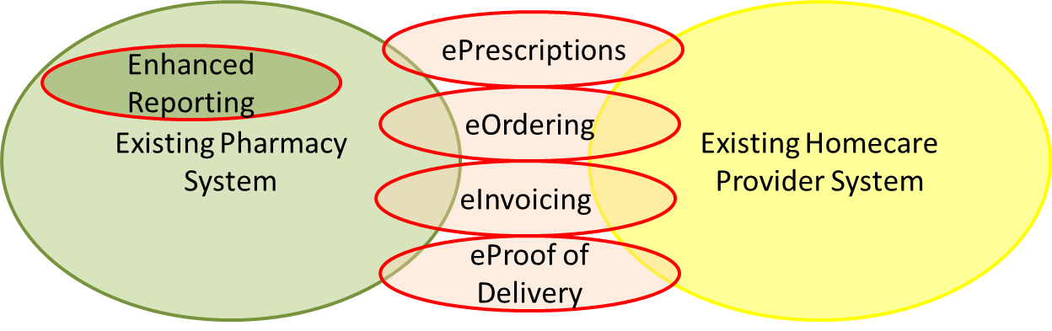
This option would build on existing Pharmacy and Homecare Provider systems and simply link them electronically via a 3rd party communication tool (such as Medecator) to electronically transfer:
- Orders
- Invoices
- Proof of Delivery
Homecare Orders could also be automatically generated from electronic Prescriptions; however this would require that the Trust already uses an electronic prescription system (see Appendix 3 for an example) which could be extended for Homecare Prescriptions.
This option could be enhanced further by adding a Reporting module for standard KPIs and other Management Information.
Fully implementing this option would remove the re-typing and scanning “Hot Spots”.

Option 2 - Link Existing System Electronically (& Stock Control Module)
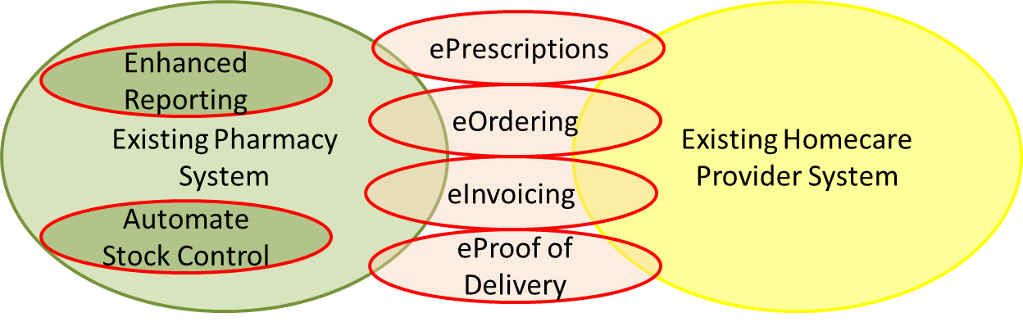
This option is an extension of Option 1, and would resolve the Reconcile & Stock Move “Hot Spots” with the addition of a Stock Control Module, which would automatically:
- reconciled/approve the Invoice & Proof of Delivery against the Order
- book stock in & out (virtually)
- cross charges directorate

North Bristol and Leeds have successfully followed this model using a low risk evolutionary strategy. They achieved this by targeting one or two “Hot Spots” at a time and then devised solutions to reduce their impact. This ensured they could then test each small change in a safe controlled manner before making it “Live” and nullifying the targeted “Hot Spots”.
Fully implementing this option would remove all “Hot Spots” highlighted above.

Option 3 - Enhanced Homecare Provider System

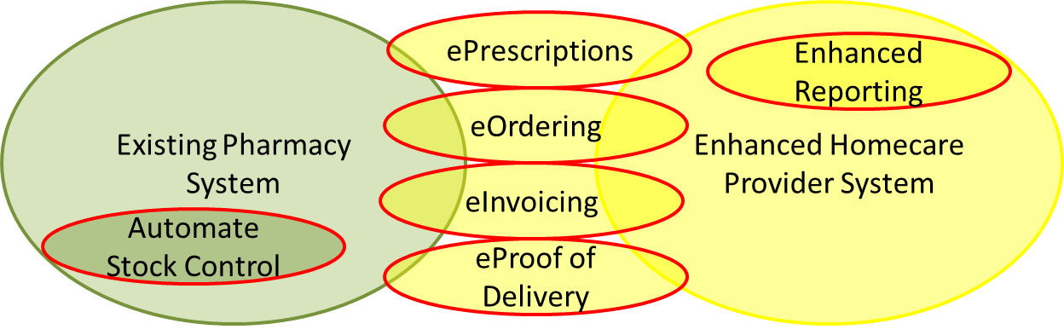This option is based on Enriched Homecare Provider System providing the bulk of the functionality with links back to the existing Pharmacy system to maintain independence (see Appendix 3 for a more detailed example how this option could be implemented)
This option could be delivered as a number of piecemeal enhancements to the existing Homecare Provider system or the Homecare Provider may choose to build a new system instead.
As with other Options - Homecare Orders could also be automatically generated from electronic Prescriptions; however this would require that the Trust already uses an electronic prescription system (see Appendix 3 for an example) which could be extended for Homecare Prescriptions.
Fully implementing this option would remove all “Hot Spots” highlighted above.

Option 4 – New Centralised Pharmacy System
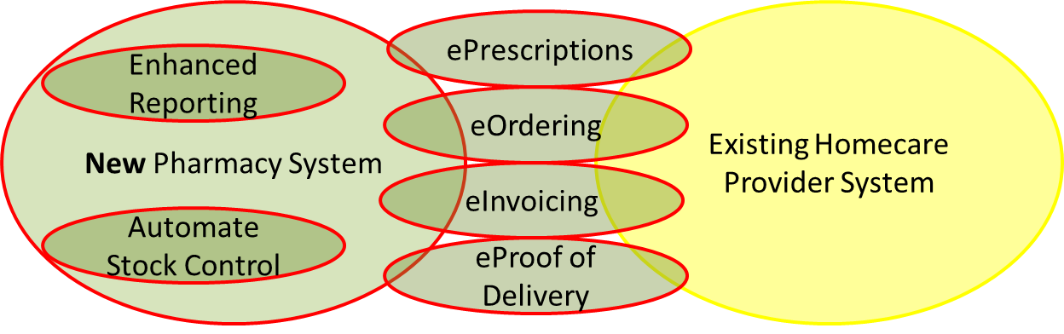
This option is based on a New Centralised Pharmacy System providing the bulk of the functionality with links to the existing Homecare Provider system, so the Provider can organise the deliveries (see Appendix 3 for a more detailed example how this option could be implemented).
As with other Options - Homecare Orders could also be automatically generated from electronic Prescriptions; however this would require that the Trust already uses an electronic prescription system (see Appendix 3 for an example) which could be extended for Homecare Prescriptions.
Fully implementing this option would remove all “Hot Spots” highlighted above.

Recommended Option
As mentioned earlier there is no “one size fits all” due to the diversity of the Trusts.
The following table shows the relative pros and cons alongside each other for the above options:
Option | Advantages | Disadvantages
1. Link Existing System Electronically | - Low risk evolutionary can be taken  - Easy to build separate components  - Facilitates controlled testing  - Small changes reduces business impact as they can be accommodated in the normally working day  - Small changes reduces training needs as the changes can be taught “on-the-job”  - Zero or little downtime for each release | - Takes-time and potentially slower to nullify all the “Hot Stops”  - Requires a lot of 3rd party and/or Homecare provider co-operation  - Difficult quantity whether this option is more or less expensive the Option 4 especially when the impact on business change is accounted for, plus each Trust is different
2. Link Existing System Electronically (& Stock Control Module) | Ditto, but delivers more functionality | Ditto
3. Enhanced Homecare Provider System | - No direct cost to the Pharmacy  - Delivery risks mainly sit with the Homecare provider | - Pharmacy have reduced control over the functionality and delivery timescales  - Requires staff re-training  - Transition from old to new systems likely to require some/significant downtime
4. New Centralised Pharmacy System | - Pharmacy have more control over the functionality and delivery timescales  - Potentially faster to nullify all the “Hot Stops” | - Direct cost to the Pharmacy  - Pharmacy are ultimately responsible of the risks  - Higher risk of late delivery  - Requires staff re-training  - Transition from old to new systems likely to require some/significant downtime  - Difficult quantity whether this option is more or less expensive the Option 1 or 2 especially when the impact on business change is accounted for, plus each Trust is different
5. Hybrid option of any of the above | A hybrid option may allow a Trust to focus on specific advantages

Logical System Components
This section shows:
- Extends the Patient Journey Overview swim-lane processes as a series of the Use Cases
- Maps the Patient Journey Overview swim-lane processes to functionality defined within the Use Cases
- Non-Functional Requirements

Functional Use Case Packages
Use Cases within this Technical System Specification describes the sequence of events within each logical system/component. So the following chapters are aligned along
The Logical system/components are (as defined in Stakeholders):
- Patient
- Clinical
- Pharmacy
- Homecare Providers
- Pharmacy & Trust Finance
- The following Stakeholders only have access to the KPIs & Reports:
  - NHS Commercial
  - Governance
  - Commissioners
  - Dept of Health / Commercial Medicines Unit

Non-Functional Requirements
Throughout any developing systems involved in the provision of NHS pharmacy services it is a requirement that all relevant applicable data standards are incorporated to ensure interoperability and comply with NHS requirements.
The following lists the ESSENTIAL components that MUST be used in a Homecare system.
- The NHS number – as required by the NPSA safer practice notice (Risk to patient safety of not using the NHS Number as the national identifier for all patients) & the NHS Operating Framework 12/13
- NHS Organisation Data Service code (also known as NACS) – e.g. RLQ
- NHS Dictionary of Medicines and Devices (dm+d) – all prescribing and medication related transfers of information MUST use dm+d coding http://dmd.medicines.org.uk/DesktopDefault.aspx
- Standard Dosing Syntax must also be used with the dm+d
- HL7 the international framework (and related standards) for the exchange, integration, sharing, and retrieval of electronic health information.
- ICD10 - the International Statistical Classification of Diseases and Related Health Problems (ICD), a medical classification list developed and maintained by the World Health Organization (WHO).
- Royal College of Physicians standards for health and social care electronic records (as defined in Appendix 1).
- Compliance with the EU Falsified Medicines Directive including options for capturing batch number and expiry dates PLUS the ability to capture and record any form of serialisation numbering.
- NHS eClass – the bespoke classification system for products and services. NHS-eClass facilitates the accurate analysis of expenditure and is now administered by NHS Shared Business Services.
- Systems utilising Electronic Transfer of Prescriptions must comply with the Prescribing Systems Compliance Specification (NPFIT-ETP-EDB-0025.20).
- All systems must utilise 128 bit encryption (or greater) for all transactions crossing public networks.
- Advanced Electronic Signatures (AES) must be used to provide secure access to any Homecare system (see also Login Use Case & Other Use Cases for other security requirements)
- Whilst proprietary systems may be used to link into the Homecare Pharmacy System all functionality must be based around open standards for IT systems to allow future developments.
- This list is not exhaustive, please also see the:
  - Framework Constraints (above)
  - Toolkit / Handbook (reference 2) and Standards (reference 9)

Use Case Mapping to Business Processes
The following table shows how the Patient Journey Overview swim-lane business processes (as column headings) map alongside the functionality defined within the Use Cases:
Use Cases | Allocate H/C Services Prescribe Drugs | Review Plan and Maintain | Check Services /Prescription for Diagnosis | Places Order For Services /Prescription | Arrange Times | Supply Services /Prescription | Get Feedback | Issue Invoice With PoD | Reconcile Invoice /Order check PoD | Pharmacy Stock Move | Cross charge Directorate | Cross charge Commissioner | Pay Homecare Provider | Capture Mgmt Information | Respond to Feedback | Gather & Produce MI / KPIs
Patient Use Cases
Choose Delivery Time |  |  |  |  | ✓ |  |  |  |  |  |  |  |  | ✓
View Patient Records |  |  |  |  | ✓ |  |  |  |  |  |  |  |  | ✓
Maintain Patient Records |  |  |  |  | ✓ |  |  |  |  |  |  |  |  | ✓
Secure Messages |  |  |  |  | ✓ |  | ✓ |  |  |  |  |  |  | ✓ | ✓
Reminders |  |  |  |  |  | ✓ | ✓ |  |  |  |  |  |  | ✓
Clinical Use Cases
Select a Patient | ✓ | ✓ |  |  |  |  |  |  |  |  |  |  |  | ✓
View Patient Records | ✓ | ✓ |  |  |  |  |  |  |  |  |  |  |  | ✓
Maintain Patient Records | ✓ | ✓ |  |  |  |  |  |  |  |  |  |  |  | ✓
Import a Prescription | ✓ | ✓ |  |  |  |  |  |  |  |  |  |  |  | ✓
Secure Messages | ✓ | ✓ |  |  |  |  |  |  |  |  |  |  |  | ✓ | ✓
Pharmacy Use Cases
Select a Patient |  |  | ✓ | ✓ |  |  |  |  |  |  |  |  |  | ✓
View Patient Records |  |  | ✓ | ✓ |  |  |  |  |  |  |  |  |  | ✓
Maintain Patient Records |  |  | ✓ | ✓ |  |  |  |  |  |  |  |  |  | ✓
Check Prescription |  |  | ✓ |  |  |  |  |  |  |  |  |  |  | ✓
Create Orders |  |  |  | ✓ |  |  |  |  |  |  |  |  |  | ✓
Place Orders |  |  |  | ✓ |  |  |  |  |  |  |  |  |  | ✓
Secure Messages |  |  | ✓ | ✓ |  |  |  |  |  |  |  |  |  | ✓ | ✓
Homecare Providers Use Cases
Select a Patient |  |  |  |  | ✓ | ✓ |  | ✓ |  |  |  |  |  | ✓
View Patient Records |  |  |  |  | ✓ | ✓ |  | ✓ |  |  |  |  |  | ✓
Maintain Patient Records |  |  |  |  | ✓ | ✓ |  | ✓ |  |  |  |  |  | ✓
Arrange Delivery |  |  |  |  | ✓ |  |  |  |  |  |  |  |  | ✓
Delivery |  |  |  |  |  | ✓ |  |  |  |  |  |  |  | ✓
Create Invoice |  |  |  |  |  |  |  | ✓ |  |  |  |  |  | ✓
Submit Invoice and Proof of Delivery |  |  |  |  |  |  |  | ✓ |  |  |  |  |  | ✓
Secure Messages |  |  |  |  | ✓ | ✓ | ✓ | ✓ |  |  |  |  |  | ✓ | ✓
Pharmacy Finance Use Cases
Select a Patient |  |  |  |  |  |  |  |  | ✓ | ✓ | ✓ |  |  | ✓
View Patient Records |  |  |  |  |  |  |  |  | ✓ | ✓ | ✓ |  |  | ✓
Reconcile Invoices and Proof of Delivery |  |  |  |  |  |  |  |  | ✓ |  |  |  |  | ✓
Process Invoice |  |  |  |  |  |  |  |  |  | ✓ | ✓ |  |  | ✓
Secure Messages |  |  |  |  |  |  |  |  | ✓ | ✓ | ✓ |  |  | ✓
Trust Finance Use Cases
Process Payment |  |  |  |  |  |  |  |  |  |  |  | ✓ | ✓ | ✓
Other Use Cases
KPIs |  |  |  |  |  |  |  |  |  |  |  |  |  | ✓ |  | ✓
Reports |  |  |  |  |  |  |  |  |  |  |  |  |  | ✓ |  | ✓

Patient Use Cases

Overview
Includes Use Cases for:
- Login & Security
- Dashboard/Homepage
- Choose Delivery Time
- View Patient Records
- Maintain Patient Records
- Secure Messages
- Reminders
- Need to check PRL for more

Login & Security
Purpose
Patient must be reassured that their data is safe.
Pre-conditions
- Patient has access to the internet, mobile-internet. An alternatively must be offered to those who can’t or haven’t got access, such as call centre number
Main Flow
- This process needs to be simple but secure and follow NHS security
- The Patient must also be able to change personnel details (e.g. contact address, phone number, password reminder, request a call, etc.)
Post conditions
- None.
Alternative Flows/Business Rules
- An alternatively must be offered to those who can’t or haven’t got internet access, such as call centre number.
- The Patient can also Log out
- The Patient is automatically Logged out after a period of inactivity
Technical Notes
- Need to follow NHS security regulations (see Homecare Handbook - reference 2)
- Patient should be able to secure access Homecare via mobile devices as well as via a computer
- Authorise Carer should be able to act as the Patient

Dashboard/Homepage
Purpose
Patient must have a central landing page from where they can access everything and see summaries.
Pre-conditions
- Patient is logged in
Main Flow
- The system displays this landing page first after the Patient logs in
- The system displays new Deliveries (which the Patient must choose a delivery time) and existing Deliveries (and the agreed delivered delivery times)
- The system also displays summaries of the Patient data (e.g. most recent Prescriptions, Homecare services, Medical Notes, Contact details, Secure Messages, FAQ, etc.)
- The Patient will also other supportive links such as: Counselling, Medicines Information, Patient Charter, Information relating to current Treatments, Medication side-effects, Leaflets, Other Language areas/sites, etc.
- The Patient can select everything they need to do from this page
Post conditions
- None.
Alternative Flows/Business Rules
- The Patient may want to change what is displayed on the dashboard
Technical Notes
- All Patient screens will be in English as a priority, but will also support access to other information (e.g. leaflets, other websites, etc.) in other languages
- Unless stated otherwise, the system always returns the Patient to this page

Choose Delivery Time
Purpose
Patient selects when they wish to receive their medication and/or Homecare services.
Pre-conditions
- The Patient has received notification that their Prescription / Order is ready for delivering via their preferred contact method
- Patient is logged in
Main Flow
- The system displays all the Prescriptions / Orders ready to be delivered
- The Patient selects a Prescription / Order
- The system displays available delivery date/times
- The Patient selects the most convenient delivery date/time and enters any additional delivery instructions
- The system sends a reminder notification before the delivery
Post conditions
- The Order/Delivery has been Arranged.
Alternative Flows/Business Rules
- The same Use Case can be used to view delivery details, change the time of the delivery, or cancel deliveries and rescheduled for later.
- The same Use Case can be used by Homecare Provider to arrange delivery details on the phone with the patient
- As well as NHS Patients some provision is needed in the future for private Self-funding patients (e.g. IVF). These patients would need a mechanism to be invoiced separately by the Homecare system. This is a lower priority requirement so and hence not mandatory for the initial implementation.
Technical Notes
- The timings of the reminder notification should be a system-wide configurable parameter.

View Patient Records
Purpose
Patient can view the medical records, previous Prescriptions and Homecare services.
Pre-conditions
- Patient is logged in
Main Flow
- The Patient can select either:
  - View My Medical Notes (Care plan, etc.)
  - View My Previous Prescriptions and Deliveries
  - View My Previous Homecare services
  - View My Needs (medical capability/help required, suitability of home Homecare services
- The Patient can select any of the above for a full description
Post conditions
- None.
Alternative Flows/Business Rules
- The same Use Case can be used by Clinical, Pharmacy, Homecare Provider to view patient data
Technical Notes
- Existing Trust systems should be used to View Patient data - any new system would only require a summary of patient data to be transferred electronically to the Pharmacy/Homecare Pharmacy Systems plus any specific delivery instructions and any homecare treatment instructions.

Maintain Patient Records
Purpose
Patient can correct some personnel details such as Telephone Number, address, etc.
Pre-conditions
- Patient is logged in
Main Flow
- The Patient can view their details Using Use Case View Patient Records
- The Patient can chose to change some of their details
Post conditions
- None.
Alternative Flows/Business Rules
- The same Use Case can be used by Clinical, Pharmacy, Homecare Provider to change patient data
Technical Notes
- Existing Trust systems should be used to Maintain Patient data - any new system would only require a summary of patient data to be transferred electronically to the Pharmacy/Homecare Pharmacy Systems plus any specific delivery instructions and any homecare treatment instructions.

Secure Messages
Purpose
Patient can send and receive secure messages, e.g. Patient Requests, Feedback, etc.
Pre-conditions
- Patient is logged in
Main Flow
- The Patient can send messages, e.g.:
  - Patient Requests to Homecare Provider, who would disseminate to the appropriate department, e.g. Delivery Services, Homecare Services, Pharmacy, Clinicians, etc.
  - Feedback
  - Clinical questions
  - Compliments and Complaints
  - Adverse Drug Events (yellow card alerting)
  - Please call me back
  - Responses to yearly Surveys
Post conditions
- None.
Alternative Flows/Business Rules
- Can answer the Patient message securely
- Can initiate and send a secure message to the Patient
- Prompted Feedback after a delivery, e.g.:
- Was it on time
- Was it complete
- Attitude and appearance of driver
- Were you happy with your delivery
- The same Use Case can be used by Clinical, Pharmacy, Homecare Provider to exchange messages with the patient securely
Technical Notes
- Need to follow NHS security regulations (see Homecare Handbook - reference 2)

Reminders
Purpose
Patient can receive notifications, e.g. text or email alerts when drugs will are due to be delivered so the patient will be at home, etc.
Pre-conditions
- Patient email and/or telephone number is know
Main Flow
- The Patient can receive an notification via email or text or both
- The Patient can receive an notification for many reasons, e.g.:
  - Patient Requests to Homecare Provider, who would disseminate to the appropriate department, e.g. Delivery Services, Homecare Services, Pharmacy, Clinicians, etc.
  - Feedback
  - Please call me back
  - Responses to yearly Surveys
Post conditions
- None.
Alternative Flows/Business Rules
- Clinical, Pharmacy, Homecare Provider can block reminders to certain patients
- Clinical, Pharmacy, Homecare Provider can configure (set-up) reminders, for example:
- when drugs will are due to be delivered so the patient will be at home
- when next appoint is due
- request for feedback
Technical Notes
- Need to follow NHS security regulations (see Homecare Handbook - reference 2)

Clinical Use Cases

Overview
Includes Use Cases for:
- Login & Security
- Dashboard/Homepage
- Selects a Patient
- View Patient Records
- Maintain Patient Records
- Import a Prescription
- Secure Messages
Existing Trust systems should be used for the following and then transferred electronically to the Pharmacy/Homecare Pharmacy Systems:
- Maintaining Patient data – any new system would only require a summary of patient data plus any specific delivery instructions and any homecare treatment instructions
- Consultation Diagnosis – any new system would only require a summary of the diagnosis and any homecare treatment instructions
- View Available Products (e.g. drugs) – This should be provided be another Trust system, so no Use Case required
- Create a Prescription – any new system would only require a copy of the prescription and any alterations
Once the Prescription is created and imported into the Homecare Pharmacy System, the Homecare electronic Prescription must be considered to be the master and only Prescription (to avoid duplicates). Therefore, existing Trust systems may need to be configured to prevent changes to Homecare Prescriptions.

Login & Security
Same as for the Patient use case, except the Clinician will have different access levels and be required to use Advanced Electronic Signatures (AES)

Dashboard/Homepage
Same as for the Patient use case, except the Clinician will have short-cuts to functionality/data they most need

Select a Patient
Purpose
Clinician can find a Patient and all their associated details.
Pre-conditions
- Clinician is logged in
Main Flow
- The Clinician can search by a number of methods, for example:
  - Trust/Hospital number
  - NHS number
  - Patient Name
  - Date of Birth
  - Address
- A list of matching Patients are displayed
- The Clinician can view more detailed patients data to confirm they have the correct patient (see View Patient Records)
- The Clinician can chose to update the patients data (see Maintain Patient Records)
Post conditions
- None.
Alternative Flows/Business Rules
- The same Use Case can be used by Pharmacy, Homecare Provider to select a patient data
Technical Notes
- Existing Trust systems should be used to View & Maintain Patient data - any new system would only require a summary of patient data to be transferred electronically to the Pharmacy/Homecare Pharmacy Systems plus any specific delivery instructions and any homecare treatment instructions.

View Patient Records
Same as for the Patient use case, except the Clinician will have access to more Patient data

Maintain Patient Records
Same as for the Patient use case, except the Clinician will be able to modify more Patient data

Import a Prescription
Purpose
Clinicians create a Homecare Prescription for drugs and services in the existing Trust systems which need to be transferred electronically from EPS into the Homecare Pharmacy System.
The Prescription imported/created by this Use Case must be the master Prescription and must only exist as an electronic Prescription (any printed prescriptions can only be considered as temporary copies).
Pre-conditions
- Clinician has recorded the Diagnosis & Prescription in the Trust system and Homecare is selected for the Patient
Main Flow
- The System periodically transfers Prescriptions into the Homecare Pharmacy System, which includes:
  - Patient Data
  - Summary Consultation Diagnosis
  - An electronic version of the Prescription
Post conditions
- None
Alternative Flows/Business Rules
- Depending on existing Trust systems, there may also be a need to Create Prescriptions electronically within the system perhaps for repeat prescriptions
- Add new Homecare drugs/services and remove discontinued drugs/services
Technical Notes
- This Use Case is likely to run as a background process, which imports all Homecare Prescriptions from EPS (see Appendix 3)
- The electronic Prescription imported/created by this Use Case must be the master Prescription and must only exist as an electronic Prescription. Furthermore, any printed prescriptions can only be considered as temporary copies, as the electronic prescription may be changed after a prescription is printed. If this is not the case then extra manual/business processes will be needed to cross-check the electronic and paper prescriptions
- The Prescriptions must use the agreed NHS Dictionary of Medicines and Devices (dm+d) http://dmd.medicines.org.uk/DesktopDefault.aspx and the Standard Dosing Syntax

Secure Messages
Same as for the Patient use case

Pharmacy Use Cases

Overview
Includes Use Cases for:
- Login & Security
- Dashboard/Homepage
- Selects a Patient
- View Patient Records
- Maintain Patient Records
- Check Prescription
- Create Orders
- Place Orders
- Secure Messages
Existing Trust systems should be used for the following and then transferred electronically to the Pharmacy/Homecare Pharmacy Systems:
- Maintaining Patient data – any new system would only require a summary of patient data plus any specific delivery instructions and any homecare treatment instructions
- Consultation Diagnosis – any new system would only require a summary of the diagnosis and any homecare treatment instructions
- View Available Products (e.g. drugs) – This should be provided be another Trust system, so no Use Case required
Once the Prescription is created and imported into the Homecare Pharmacy System, the Homecare electronic Prescription must be considered to be the master and only Prescription (to avoid duplicates). Therefore, existing Trust systems may need to be configured to prevent changes to Homecare Prescriptions.
A future requirement would be the standardised ancillary items including Nursing input, patient training, etc. This is a lower priority requirement so and hence not mandatory for the initial implementation.

Login & Security
Same as for the Clinician use case, except the Pharmacy will have different access levels and be required to use Advanced Electronic Signatures (AES)

Dashboard/Homepage
Same as for the Clinician use case, except the Pharmacy will have short-cuts to functionality/data they most need

Select a Patient
Same as for the Clinician use case, except the Pharmacy may have different data access levels to Patient data

View Patient Records
Same as for the Clinician use case, except the Pharmacy may have different data access levels to Patient data

Maintain Patient Records
Same as for the Clinician use case, except the Pharmacy may have different data access levels to Patient data

Check Prescription
Purpose
Pharmacy need to check the Prescription
Pre-conditions
- The Prescription has been imported into the Homecare Pharmacy System
Main Flow
- The Pharmacy Clinician reviews each newly imported Prescription in-turn (using View Patient Records):
  - The Pharmacy Clinician can correct the Prescription (using Maintain Patient Records)
  - The Pharmacy Clinician confirms they have “Checked” the Prescription
- The Prescriber (e.g. Doctor, Nurse, another Pharmacist, etc.) is notified of any corrections applied
Post conditions
- The Prescription has been Checked
Alternative Flows/Business Rules
- None
Technical Notes
- Provide a Stop facility for patients previously on homecare including information on anticipated patient held stocks

Create Orders
Purpose
Pharmacy need to create an Order from a Prescription
Pre-conditions
- Pharmacy has Checked the Prescription (see Check Prescription)
Main Flow
- This Use Case could be triggered automatically by the System periodically or manually by the Pharmacy
- The System considers each newly checked Prescription in-turn and generates orders following rules set-up for this Use Case (probably as a background process), such as:
  - A Prescription can have many Orders, but an Order cannot have many Prescriptions
  - One Order is created for each Delivery (1 to 1)
  - One Order is created for each Invoice (1 to 1)
  - Order should use dm+d and the Standard Dosing Syntax
  - Only Homecare Drugs can be used. These need to kept separate from the normal Pharmacy drugs for VAT/accounting reasons
  - Homecare drugs are only ordered singularly (not in packs), this way Homecare providers are not left with half packs and the Pharmacy are only charged for the pills they requested
  - Some drug types may have special delivery requirements which could be defined as a set of rules
  - Larger dosage may need splitting up into separate deliveries
  - Homecare contract may impact on these rules, e.g. standard delivery charge may be included in the drug price or always consider as extra order item

- The Pharmacy Procurement validates the newly created Orders using the Checked Prescriptions together
- The Pharmacy Procurement “Approves” the newly created Orders
Post conditions
- The Orders have been Approved
Alternative Flows/Business Rules
- The automatic Order creation rules must be maintained, so these can be tailored regularly to make this process as efficient as possible. Only supervisor/manager should have access to these rules
- Some Orders may still need to created manually, however the business should look to refine the Order creation rules to reduce these circumstances
- Transfer patients between: Homecare provider, Care setting and Commissioner’s
Technical Notes
- None

Place Orders
Purpose
Sends the Orders and Prescriptions to the Homecare Provider(s).
Pre-conditions
- Orders have been Approved
Main Flow
- The System periodically transfers the Orders and the corresponding Prescriptions the Homecare Provider system(s)
Post conditions
- Orders are consider Placed by the Homecare Pharmacy System
Alternative Flows/Business Rules
- None
Technical Notes
- None

Secure Messages
Same as for the Patient use case

Homecare Providers Use Cases

Overview
Includes Use Cases for:
- Login & Security
- Dashboard/Homepage
- Selects a Patient
- View Patient Records
- Maintain Patient Records
- Arrange Delivery
- Delivery
- Create Invoice
- Submit Invoice and Proof of Delivery (PoD)
- Secure Messages
Depending on the Trust & Homecare Provider arrangements some of the existing Homecare Provider systems should be used for the above Use Cases, for example:
- Arrange Delivery
- Make Delivery
- Create Invoice
- Submit Invoice and PoD

Login & Security
Same as for the Clinician use case, except the Homecare Providers will have different access levels and be required to use Advanced Electronic Signatures (AES)

Dashboard/Homepage
Same as for the Clinician use case, except the Homecare Providers will have short-cuts to functionality/data they most need

Select a Patient
Same as for the Clinician use case, except the Homecare Providers may have different data access levels to Patient data

View Patient Records
Same as for the Clinician use case, except the Homecare Providers may have different data access levels to Patient data

Maintain Patient Records
Same as for the Clinician use case, except the Homecare Providers may have different data access levels to Patient data

Arrange Delivery
Purpose
Homecare Provider organise delivery with the Patient
Pre-conditions
- An Order has been Placed
Main Flow
- For each newly Placed Order the Homecare Provider reviews Order, Prescription and Patient details in-turn (using View Patient Records)
- The Homecare Provider contacts each Patient in-turn (using Choose Delivery Time) to arrange a delivery date & time, and any special delivery details
- The System set-up reminder(s) for the Patient (using Patient Reminders)
Post conditions
- The Patient has been approached to determine the delivery date & time
Alternative Flows/Business Rules
- The Homecare Provider may contact the Patient via other means, either:
  - Secure Messaging
  - Email
  - text
  - or with a phone call
Technical Notes
- If this functionality resides on the Homecare Providers System then a connection may be required to initiate Patient Reminders and update the Patients Dashboard

Delivery
Purpose
Homecare Provider delivers the Drugs and any Homecare Services to the Patient
Pre-conditions
- Delivery Arrangements, Date & Time has been agreed
- Drugs have been picked from the Homecare Providers pharmacy, packaged and labelled (see Homecare Handbook - reference 2)
Main Flow
- Homecare Provider delivers the Drugs / Homecare Services to the Patient
- Homecare Provider obtains Proof of Delivery from the Patient
- Homecare Provider may make an observation whilst making the Delivery (e.g. previous drugs not used, Patient looks unwell, etc.)
- The system sends a reminder to the Patient for delivery feedback (using Patient Reminders and Secure Messaging)
Post conditions
- Patient has received Drugs / Homecare Services
- The Order/Delivery have been Delivered
Alternative Flows/Business Rules
- Patient “not in”, so the Delivery will need to be re-arranged (using Arrange Delivery)
Technical Notes
- If this functionality resides on the Homecare Providers System then a connection may be required to initiate Patient Reminders and update the Patients Dashboard

Create Invoice
Purpose
Homecare Provider creates a virtual Invoice which should match the Order precisely.
Pre-conditions
- The Order/Delivery have been Delivered
Main Flow
- This Use Case could be triggered automatically by the System periodically or manually by the Homecare Provider
- The System considers each newly Delivered Order in-turn and generates a corresponding Invoice orders following rules set-up for this Use Case (probably as a background process), such as:
  - One Invoice is created for each Delivery (1 to 1)
  - One Invoice is created for each Order (1 to 1)
  - Invoice should use dm+d and the Standard Dosing Syntax
- The Homecare Provider validates the newly created Invoices using the Orders
- The Homecare Provider “Approves” the newly created Invoices
Post conditions
- The Invoice have been Approved
Alternative Flows/Business Rules
- The automatic Invoice creation rules must be maintained, so these can be tailored regularly to make this process as efficient as possible. Only supervisor/manager should have access to these rules
Technical Notes
- Some Trusts may decide to this Use Case one step further by coming to the conclusion that the Invoice is no longer required as the Invoice exactly matches the Order. This therefore also means that cross checking/validation is no-longer required

Submit Invoice and Proof of Delivery
Purpose
Sends the Invoice and Proof of Delivery (PoD) to Pharmacy Finance
Pre-conditions
- Invoices have been Approved
Main Flow
- The System periodically transfers the Invoices and the corresponding PoDs to the Homecare Pharmacy System
Post conditions
- Invoices are consider Placed by the Homecare Pharmacy System
Alternative Flows/Business Rules
- None
Technical Notes
- None

Secure Messages
Same as for the Patient use case

Pharmacy Finance Use Cases

Overview
Includes Use Cases for:
- Login & Security
- Dashboard/Homepage
- Selects a Patient
- View Patient Records
- Reconcile Invoices and Proof of Delivery (PoD)
- Process Invoice
- Secure Messages

Login & Security
Same as for the Clinician use case, except the Pharmacy Finance will have different access levels and be required to use Advanced Electronic Signatures (AES)

Dashboard/Homepage
Same as for the Clinician use case, except Pharmacy Finance will have short-cuts to functionality/data they most need

Select a Patient
Same as for the Clinician use case, except Pharmacy Finance may have different data access levels to Patient data

View Patient Records
Same as for the Clinician use case, except Pharmacy Finance may have different data access levels to Patient data

Reconcile Invoices and Proof of Delivery
Purpose
Matches the Invoice with the Order and checks for Proof of Delivery (PoD)
Pre-conditions
- Batch of Invoices and PoDs have been received from the Homecare Provider
- Predefined matching rules between the Invoices and Orders must be set-up beforehand (see Alternate Flow below)
Main Flow
- This Use Case could be triggered automatically by the System periodically or manually by the Pharmacy Finance
- The System attempts the transfer the Invoices and corresponding PoDs with the Orders using predefined rules, such as:
  - Order Number
  - One Invoice should be created for each Order (1 to 1)
  - Drugs (using dm+d and the Standard Dosing Syntax)
  - Services required
  - Amount prescribed and duration
  - Patient details
  - Order/Delivery date
  - If it’s not possible check the above on the PoD, then check to ensure the PoD exists and perhaps PoD date
- The System “Automatically Approves” the newly received Invoices that pass the matching rules
- The Pharmacy Finance manually “resolves” the Invoices and corresponding PoDs that failed the matching rules
- The Pharmacy Finance “Fully Approves” the received Invoices
Post conditions
- The Invoices have been Fully Approved
Alternative Flows/Business Rules
- Invoice “resolution” may include rejecting the Invoice, re-matching the invoice/order manually, override the automatic rules, etc.
- The automatic matching rules between the Invoices and corresponding PoDs with the Orders must be maintained, so these can be tailored regularly to make this process as efficient as possible. Only supervisor/manager should have access to these rules
Technical Notes
- This Use Case needs to very flexible and easy to use as reconciliation can get very complex, especially when Invoices are late and repeat prescriptions

Process Invoice
Purpose
Once the Invoice has been approved the Invoice can be automatically processed (e.g. Stock Control Module, Cross Charge Directorate, Pay Invoice, etc.), this Use Case may differ for each Trust
Pre-conditions
- Invoices are Fully Approved
Main Flow
- This Use Case could be triggered automatically by the System periodically or manually by the Pharmacy Finance
- The System processes each Invoice in-turn. Please note, this may differ for each Trust, but may include:
  - Virtually booking stock/drugs in & out of the Pharmacy (Stock Control Module)
  - Cross charging the Directorate for the drugs/services for the Prescription
  - Instruction Trust Finance to pay the invoice
- The System considers the Invoice as “Submitted for Payment”
Post conditions
- The Invoices have been Submitted for Payment
Alternative Flows/Business Rules
- This Use Case could be totally automated, but occasionally Pharmacy Finance might need to manually Process an Invoice
- Marking stock as Wasted (e.g. stock going out of date, unused deliveries, stock not used when patients die, etc.). This is a lower priority requirement so and hence not mandatory for the initial implementation.
Technical Notes
- This Use Case might need to configurable as each Trust may differ
- This Use Case must follow NHS accounting rules

Secure Messages
Same as for the Patient use case, except Pharmacy Finance may have different data access levels as Finance shouldn’t be able to contact Patient

Trust Finance Use Cases

Overview
Includes Use Cases for:
- Process Payment
Most likely that this Use Case will be facilitated by existing Trust Finance system rather than a specific Homecare system. This Use Case is only included in this document for completeness, as for example the existing Trust Finance system could be enhanced with the following functionality/automation

Process Payment
Purpose
Once the Invoice has been approved the Invoice can be automatically processed (e.g. Stock Control Module, Cross Charge Directorate, Pay Invoice, etc.), this Use Case may differ for each Trust
Pre-conditions
- The Invoices have been Submitted for Payment
Main Flow
- This Use Case could be triggered automatically by the System periodically or manually by the Trust Finance
- The System processes each Invoice in-turn. Please note, this may differ for each Trust, but may include:
  - Submit Invoices for other Trust to the appropriate Commissioner for cross charging
  - Add the payment of the invoice to the next payment run
- The System considers the Invoice as “Submitted for Payment”
Post conditions
- The Invoices have been Paid
Alternative Flows/Business Rules
- This Use Case be totally automated, but occasionally Trust Finance might need to manually Process an Invoice
Technical Notes
- This Use Case must follow NHS accounting rules

Other Use Cases

Overview
Includes Use Cases for:
- KPIs
- Reporting - Reports available by total, drug, therapy, budget code, date/month supplier and or patient

Other Security/Access Control Use Cases are also likely to be required, and be required to use Advanced Electronic Signatures (AES). However, as these will be governed by the off-the-shelf system solution chosen by the Trust these have not been expanded in this document, for example:
- Maintain Data Structure – as different depts/organisations will need to see more or less detail (for example patient records)
- Maintain Roles – use Roles to manage groups of Users
- Maintain User Access – adding Users to Roles
- Change User Password
- Maintain User Details – e.g. Name, Address, Phone, Organisation, etc.
- Maintain Organisation Details – e.g. Name, Address, Phone, Mgr, etc.
- Forgotten Password
- Logging out
- Session Time out

KPIs
Purpose
A list of KPIs is available in the Homecare Handbook (see reference 2)
Pre-conditions
- None
Main Flow
- This Use Case could be triggered automatically by the System periodically or manually by a User
- This User selects the KPI they wish look at
- The system produces/displays the KPI information
- The User may wish to Benchmark the KPI, for comparison next time
- The User may wish to extract the information (for further analysis, e.g. into Excel)
- The User may wish to print the KPI
Post conditions
- KPI produced
Alternative Flows/Business Rules
- None
Technical Notes
- Please note, some KPIs may be for Management only

Reports
Purpose
Any system must provide a flexible and comprehensive reporting tool to allow appropriately authorised and audited data extraction. Therefore, a list of Standard Reports is likely to be needed (e.g. Patient summary, Patient Diary, Full Audit History, Prescriptions, Delivery Failures, Patient Satisfactory, Incident, Wastage, Financial, Adverse Drug Events, QIPP, etc.), as well as the ability to produce ad-hoc reports.
Pre-conditions
- None
Main Flow
- This Use Case could be triggered automatically by the System periodically or manually by a User
- This User selects the Standard Report they wish look at
- The system produces/displays the Report information
- The User may wish to extract the information (for further analysis, e.g. into Excel)
- The User may wish to print the Report
Post conditions
- Report produced
Alternative Flows/Business Rules
- Ad-hoc reporting functionality should be available so Users can build their own reports to support their work. These ad-hoc reports should be preserved so they can by re-run at a later date
- All Reports can be filtered (e.g. by patient, directorate, commissioner, England wide, cross border activity, clinical condition with medication type, homecare provider, etc.)
Technical Notes
- Please note, some Homecare information may need to be restricted to certain users

Appendix 1 – RCP Health and Social Care Standards for Electronic Records
Currently there is no overarching body responsible for health and social care standards held electronically and passed between IT systems. The Joint Working Group with the Royal College of Physicians (RCP) was set up at the request of the Department of Health to examine the development of Electronic Health Records and recommend how professional requirements and leadership could best support the development of Electronic Health Records (EHRs) in line with national policy.
The following tables shows the agreed standard terminology the Department of Health will be using moving forwards for all medical and health matters (not just Homecare).
Preferred Headings | Preferred Description | Technical Notes
MEDICATIONS & MEDICAL DEVICES
Medication Name | Generic name (with brand name - as appropriate). | Medication name is an attribute of a medication record.  Use NHS Dictionary of Medicines and Devices (dm+d)
Medication Form | For example caplet, drops, tablet, lotion etc | Medication form is an attribute of a medication record.  Form is more commonly used in primary than secondary care, but may be used in secondary care.  Use NHS Dictionary of Medicines and Devices (dm+d).
Dose | Unit of measurement, e.g. number of tablets (2 tabs) medications content (e.g. 20mg) | Medication dose is an attribute of medication record.  This is a record of the dose at each administration. It is a combination of ingredient strength and ingredient quantity. Where combination medication eg co-amoxyclav, it may be number of tablets where a single drug, eg. Furosemide, it may be the exact quantity e.g. 20mg. Check with JW. IMcN, JGW  Use NHS Dictionary of Medicines and Devices (dm+d) and the Standard Dosing Syntax  Allow for mass per unit volume format, to allow for liquid preparations.  Consider CUI display formatting
Route | Medication Administration Description (oral, IM, IV, etc): May include method of administration (e.g. by infusion, via nebuliser, via NG tube) and/or site of use (e.g. ‘to wound’, to left eye, etc). | Medication route is an attribute of medication record.  Use SNOMED Routes termset
Medication Frequency | Frequency of taking or administration of the therapeutic agent or medication. | Medication frequency is an attribute of medication record.  It is used in dose based prescribing where frequency is identified separately.  Plain text or CFH dose syntax
Special Requirements | Allows for:  * Requirements for adherence support, for example compliance aids, prompts and packaging requirements  * Additional information about specific medicines, for example, brand name or special products where bioavailability or formulation issues | ‘Special requirements’ is an attribute of medication record.  It was known as 'additional instructions' in CFH dose syntax model.  Plain text or CFH dose syntax
Do not discontinue warning | To be used on a case by case basis if it is vital not to dis-continue a medicine in a specific patient scenario | Do not discontinue warning is an attribute of medication record.  Plain text
Reason for medication | Reason for medication being prescribed, where known | Reason for medication is an attribute of medication record.  Plain text
Medication status | Status of the medication, i.e. started, stopped, discontinued, suspended, re-instated, reviewed.  Record date for each change in status | Medication status is an attribute of medication record.  Plain text  Can it be coded? Is there a standard list? JW/IMcN to advise please.
Medication change | Where a change is made to the medication status or to the dose, form, frequency or route, the information is displayed as medication change. | Medication change is an attribute of medication record.  Plain text or drop down of type of change  This is very similar to medication status. Is this something that is displayed when the status has changed during a hospital episode as ‘medication changes’ when communicating between care settings?
Reason for medication change | Reason for change in medication, e.g. sub-therapeutic dose, patient intolerant | Reason for medication change is an attribute of medication record related to medication status.  Plain text
Medicine administered | Record of administration to the patient, including self-administration. | Part of the drug administration record.  Date administered and by whom.
Reason for non-administration | Reason why drug not administered (e.g. patient refused, patient unavailable, drug not available). | Part of the drug administration record.  Plain text
Relevant Previous Medications | Record of relevant previous medications | Use NHS Dictionary of Medicines and Devices (dm+d) and the Standard Dosing Syntax, where possible, but may be plain text, e.g. where patient is providing the information.  Relevant previous medications to be communicated between healthcare settings in addition to current medications
Medication Recommendations | Suggestions about duration and or review, ongoing monitoring requirements, advice on starting, discontinuing or changing medication. | Plain text  Medication recommendations to be communicated between healthcare settings where relevant.
Medical devices | The record of dietary supplements, dressings and equipment that the patient is currently taking or using.  Data items:  *Device name  * Device Identifier  *Batch number  *Serial number | The data items are attributes of medical device record.  Also record start and stop dates, where relevant.  Use NHS Dictionary of Medicines and Devices (dm+d) and the Standard Dosing Syntax only for prescribable devices.  Increasing numbers of medical devices contain active pharmacological ingredients. Medical devices should not therefore be separated from medicines in the viewable record.

Appendix 2 – Ideal Patient Journey
The Patient Journey Overview swim-lane is gives an overview of the patient journey through Homecare prescription / dispensing from a Patient prospective which drive the requirements. The section below shows the ideal patients journey pictorially, however this Prezi presentation is better observed online http://prezi.com/nbwxm-veksbx/copy-of-homecare-blue-sky/?auth_key=e0c030d774ff56e3bf514c7bbcfeea563fa26c19&kw=view-nbwxm-veksbx&rc=ref-79449 :

Figure 3 - Homecare prescription / dispensing from a Patient prospective

Appendix 3 – Technical Option Examples

Centralised Pharmacy System Option
Figure 3 shows how the Homecare stakeholders systems might logically communicate with the Homecare “core” system, via the use of standard services under strict security control.
Figure 3 shows four types of interfaces, but the eventually system may support more (or less):
- Internet Portal – for the more simpler user transactions and lightweight reporting (such as MI, KPIs)
- Business Services – for real-time systems connectivity
- Data Download and Upload – for periodic data updates between systems, e.g. nightly
- Data Download – for bulk data extract, e.g. populating data warehouses
These types of have been used for the following stakeholders:
- Majority of the Stakeholders will use an Internet Portal connection to access the central Homecare Pharmacy System, i.e.: Patients, Commissioner, DH and CMU, NHS Governance, NHS Commercial and Finance
- However as there are at least 8 Pharmacy systems, each system will have different communication requirements and software restrictions hence the “core” system needs to provide alternative interface options. Plus the Pharmacist may wish to use the Portal as well
- Similarly for the different Clinical systems and Homecare Provider systems
- Finance may also require periodic data extracts, e.g. for cross charging
- All interfaces will use the Royal College of Physicians (RCP) standardised the Electronic Health Records terminology as listed in Appendix 1
Figure 4 - System Architecture Central Example

Enhanced Homecare Provider System Option
There is an extended version of the above central architecture which has some benefits (including cost). A Homecare provider may wish to develop a system or extend their existing Homecare Providers system to include the “core” functionality. The Trust would then use the Homecare Providers system as part of the Homecare services they offer.
However, as most Trusts have one Homecare Provider this host option would still need to allow for these other Homecare providers to connect in some way, which may lead to inter-commercial issues that might prevent this:
Figure 5 - System Architecture Providers Hosted Example
Please note, a Business Analysis several years ago looking at a similar problem to bring together the Pharmacy systems, called PBMS (Patient Based Medicines System) and came to an almost identical conclusion, see below:

Electronic transfer of Prescriptions Service Option
One such system that might be integrated to enhance Homecare is Electronic transfer of Prescriptions Service (EPS) in England, which could also support the transmission of both FP10 prescriptions and “private” NHS prescriptions for Homecare and out-patients. The diagram below illustrates how such a system could be developed to support changes in hospital pharmacy service provision.
Figure 6 - Vision for using EPS in Secondary care
The process flow for Figure 5 is as follows (additional new processes that could also be introduced to support Homecare dispensing have been highlight with yellow):
- This process assumes the following is known:
    - Patient's NHS number
    - prescribed medication
- The Homecare dispenser is chosen as follows:
    - If the patient has a nominated dispenser then that dispenser is used
    - If this prescription needs a specific dispenser then that dispenser is used
    - Otherwise the no dispenser selected.
- Prescription message is created and electronically approved by the prescriber
- Once approved:
    - The nominated dispenser can download their prescriptions
    - A non-nominated prescription can be downloaded using the Prescription ID. The Prescription ID is normally conveyed to the dispenser on a printed prescription token as text and a barcode. [However, the Prescription ID could be conveyed to a specific dispenser via email or another communications machanism.]
- The medication is dispensed and issued to the Patient, which:
    - sends a Dispense Notification message to EPS
    - cross charges the associated hospital directorate.
- Dispensing endorsements related to BSA prescription reimbursement are forwarded to the BSA for processing
- Each month the FP34 paper claim forms are passed to BSA, so BSA can record the number of paper and electronic prescriptions submitted for reimbursement in that month.

Appendix 4 – References

- Homecare Medicines – Towards a Vision for the Future, 2011, Hackett, Mark, Department of Health (Gateway reference 16691). A copy of the Hackett report can be found here http://cmu.dh.gov.uk/files/2011/12/111201-Homecare-Medicines-Towards-a-Vision-for-the-Future2.pdf

- Homecare Governance Toolkit for the introduction and use of medicines, 2012, from the National Homecare Steering Board Committee. Please note, this is soon to be replaced by the Homecare Handbook (March 2014). A copy of the Toolkit report can be found here http://www.keele.ac.uk/media/keeleuniversity/fachealth/fachealthsop/medmanservices/gpdpresentations/120222%20Homecare%20toolkit%20draft%20sh%20rev6-1.pdf

- The latest list of NHS Trust Centres can be obtained from: http://www.connectingforhealth.nhs.uk/systemsandservices/data/ods/datafiles/data-files

- The Operating Framework for the NHS in England 2012/13. http://www.dh.gov.uk/prod_consum_dh/groups/dh_digitalassets/documents/digitalasset/dh_131428.pdf

- National Audit Office report for prescribing costs in primary care, can be found here http://www.nao.org.uk/publications/0607/prescribing_costs_in_primary_c.aspx

- DH paper for “Improving the use of medicines for better outcomes and reduced waste”, can be found here http://www.dh.gov.uk/health/files/2012/12/Improving-the-use-of-medicines-for-better-outcomes-and-reduced-waste-An-action-plan.pdf

- College of Physicians report standardisation of the Electronic Health Records, can be found here “”.

- Output Based Specification – Precursor to this Technical System Specification

- Royal Pharmaceutical Society has published new professional standards for homecare services (Sep 2013) http://www.rpharms.com/what-s-happening-/news_show.asp?id=945

Appendix 5 – Glossary of Terms

Name | Acronym | Description
Board of Commissioners | BOC | Route for PCT to gain agreement jointly.
Benefits Tracking Tool | BTT | BTT data warehouse and integrated reporting tool.
Clinical Commissioning Group | CCG | Clinical commissioning groups are groups of GPs that will, from April 2013, be responsible for designing local health services In England. They will do this by commissioning or buying health and care services including:  - Elective hospital care  - Rehabilitation care  - Urgent and emergency care  - Most community health services  - Mental health and learning disability services
Care Quality Commission | CQC | Regulate care provided by the NHS, local authorities, private companies and voluntary organisations. They aim to make sure better care is provided for everyone - in hospitals, care homes and people’s own homes. They also seek to protect the interests of people whose rights are restricted under the Mental Health Act.
Combined Panel |  | Review panel consisted of Mark Hackett, as Chair, Steering group and Working group.
Commercial Medicines Unit | CMU | CMU work to ensure that the NHS in England makes the most effective use of its resources by getting the best possible value for money when purchasing goods and services. CMU enhance and safeguard the health of the public by ensuring that medicines and medical devices work and are acceptably safe. No product is risk-free. Underpinning all our work lie robust and fact-based judgements to ensure that the benefits to patients and the public justify the risks.
Commissioning for Quality and Innovation | CQUIN | The Commissioning for Quality and Innovation (CQUIN) payment framework enables commissioners to reward excellence by linking a proportion of providers’ income to the achievement of local quality improvement goals
Department of Health | DH | The Department of Health provides strategic leadership for public health, the NHS and social care in England.
Drug and Therapeutics Committee | DTC
Electronic Prescribing Analysis and Cost | e-PACT | A service for pharmaceutical and prescribing advisors, which allows real time on-line analysis of the previous sixty months. The prescribing data, held on NHS Prescription Services’ Prescribing Database
Electronic transfer of Prescriptions Service | EPS | Existing system which may be enhanced to support the transmission of both FP10 prescriptions and “private” NHS prescriptions for Homecare and out-patients
General Practitioner | GP | A medical practitioner who typically the first medical professional a patient will see and as such treats wide variety of illnesses and provides preventive care and health education for all ages and all sexes
Healthcare Resource Groups | HRG’s
High Cost Drugs | HCD
Home Parenteral Nutrition | HPN
Homecare |  | Homecare is defined as a service that regularly delivers medicine supplies and associated care, directly to a patient’s choice of location. Homecare services are split between those which are set up by the Pharmaceutical industry for individual products and those services which are contracted to an NHS specification
Key Performance Indicators | KPIs | Key Performance Indicators are quantifiable measurements, agreed to beforehand, that reflect the critical success factors of an organisation.
Management Information reporting | MI | Periodic reports such as KPIs
Manufacturer derived scheme |  | Process by where the manufacturers of the product works with a homecare provider to ensure their product/s are delivered to a patient at home. The NHS has no relationship or involvement with this arrangement other than paying for the product and service which is bundled together.
Multi-disciplinary team |  | Collaborative efforts of professionals from different disciplines toward a common goal. Can be made up of Consultant’s, Clinician’s, Nurses, Pharmacists and Healthcare Workers.
National Clinical Homecare Association | NCHA | Represents and promotes the interests of industries whose business is substantially to provide medical supplies and/or clinical services directly to patients in the community within an appropriate quality framework. Provide a forum for lobbying on issues that affect homecare. Set and debate policy decisions with the National Homecare Medicine Supply Committee and other relevant government bodies.
National Health Service | NHS | English Health Service.
National Institute for Health and Clinical Excellence | NICE | NICE is an independent organisation responsible for providing national guidance on promoting good health and preventing and treating ill health.
National Patient Safety Agency | NPSA | Lead and contribute to improved, safe patient care by informing, supporting and influencing organisations and people working in the health sector.  An Arm’s Length Body of the Department of Health and through three divisions covers the UK health service.
National Prescribing Centre | NPC | Supports the NHS, and those working for it, to improve quality, safety and value for money, in the use of medicines for the benefit of patients and the public
Official Journal of the European Union | OJEU | Tendering process all government organisations must use (previously called OJEC - www.ojec.com )
Output Based Specification | OBS | It can be considered as a “wrapper” to describe the functionality required of a range of different systems supporting the provision of homecare.
Payment by Results | PbR
Pharmaceutical Price Regulation Scheme | PPRS | A British mechanism for determining the prices the NHS pays for brand name drugs.
Primary Care Trust | PCT | Community patient care.
Prioritised Requirement List | PRL | Quite simply a list of requirements which have been prioritised, as listed in the OBS.
Quality, Innovation, Productivity and Prevention | QIPP | QIPP is a large scale transformational programme for the NHS, involving all NHS staff, clinicians, patients and the voluntary sector and will improve the quality of care the NHS delivers whilst making up to £20billion of efficiency savings by 2014-15, which will be reinvested in frontline care.
Royal College of Physicians | RCP | http://www.rcplondon.ac.uk/about
Serious Untoward Incidents | SUI’s | An SUI is in general terms something out of the ordinary or unexpected, with the potential to cause serious harm and/or likely to attract public and media interest that occurs on NHS premises or in the provision of an NHS or a commissioned service.
Service Level Agreement | SLA | A service level agreement (frequently abbreviated as SLA) is a part of a service contract where the level of service is formally defined. In practice, the term SLA is sometimes used to refer to the contracted delivery time (of the service) or performance.
Strategic Health Authority | SHA
Sub-contractor |  | A subcontractor is an individual or in many cases a business that signs a contract to perform part or all of the obligations of another’s contract. A subcontractor is hired by a general contractor (or prime contractor) to perform a specific takes as part of the overall project.
Trust/Organisation |  | Strategic health authorities are responsible for the performance of NHS organisations known as Trusts. This includes primary care trusts (PCTs), acute trusts, mental health trusts, Ambulance service trusts and foundation trusts. Please see Reference 3 for a full list
Unified Modelling Language | UML | Unified Modelling Language is a software development, includes a set of graphic notation techniques (e.g. Use Cases, Class Diagrams, Activity Diagrams)
Value Added Tax | VAT
Value for Money | VFM

http://cmu.dh.gov.uk/files/2011/12/111201-Homecare-Medicines-Towards-a-Vision-for-the-Future2.pdf
http://www.uhs.nhs.uk/AboutTheTrust/PlansPoliciesAndStrategies/HomecaremedicinesTowardsavisionforthefutureimplementingtherecommendations.aspx

